NHG Growing Pains: Vehicle Routing Optimization

A Capacitated Vehicle Routing Problem with Time Windows: Scenario Analysis and Logistics Cost Benchmarking

Course: IE 7200 - Supply Chain Engineering
Semester: Spring 2026
Institution: Northeastern University

Submitted by: Harshavardhan Surya Babu Sivagami & Sainath Boreda
Date: April 2026

Abstract
This report examines NHG’s weekly delivery operation through three computational scenarios, each framed as a Capacitated Vehicle Routing Problem with Time Windows (CVRPTW). NHG runs a single distribution depot in Woburn, MA, serving 123 store locations across six New England states with 261 weekly orders totaling 65,429 cubic feet of product. Routes are built and improved through a four-phase heuristic pipeline: Clarke-Wright savings construction, intra-route 2-Opt, route consolidation, and inter-route Or-Opt. All solutions satisfy the hard DOT hours-of-service, vehicle capacity, and 8:00 AM–6:00 PM time-window constraints.
Three scenarios are evaluated: a van-only base case on the existing fixed schedule (Q1), a mixed fleet with Straight Trucks for 60 restricted-access orders (Q2), and a relaxed schedule allowing geographic day-clustering of stores (Q3). Q1 establishes a baseline of 6,714 weekly miles (349,128 annually). Q2 raises this by 13.0% to 7,584 miles through route fragmentation. Q3 cuts mileage by 28.6% to 4,793 miles weekly, saving approximately 99,892 annual miles. The findings give NHG a concrete, model-validated position for evaluating a proposal from third-party logistics provider MAD.
Keywords: Vehicle Routing Problem, CVRPTW, Clarke-Wright savings, heuristic optimization, logistics benchmarking, fleet management, time windows.

Table of Contents
1. Introduction 3
2. Problem Formulation 3
3. Solution Methodology 4
4. Scenario Q1: Base Case — Vans Only 5
5. Scenario Q2: Heterogeneous Fleet 6
6. Scenario Q3: Relaxed Delivery Schedule 7
7. Comparative Analysis and Discussion 8
8. Conclusions and Recommendations 9
9. Appendix A: Notation Summary 11
10. References 11

1. Introduction
Distribution costs tend to be one of the easier logistics levers to pull — but only if you actually model the problem. For growing retailers, expanding store footprints while holding delivery operations together under fixed resources is a real planning challenge, and one that conventional scheduling approaches handle surprisingly poorly. NHG is a regional retailer that has grown to 123 store locations across Massachusetts, New Hampshire, Connecticut, Rhode Island, Vermont, and Maine, all serviced from a single depot in Woburn, MA (ZIP 01887). The network is substantial, and the inefficiencies embedded in a static Mon–Fri delivery schedule compound week over week.
Each week, 261 orders - 65,429 cubic feet of product in total — need to reach those stores between Monday and Friday. The current approach assigns each store to a fixed delivery day. That sounds orderly, but it means the routes on any given day serve stores that are not necessarily close to each other. The geographic spread adds miles, and those miles cost money. At the same time, NHG is evaluating a bid from Massachusetts Area Distribution (MAD), a third-party logistics provider. Before deciding whether to accept that bid, NHG needs to know its own operating costs— modeled carefully, not estimated loosely.
This report answers that question through three structured scenarios. Q1 builds a credible mileage baseline using a van-only fleet on the existing schedule. Q2 tests what happens when Straight Trucks — required for 60 orders with access constraints — enter the mix. Q3 relaxes the fixed schedule and lets the algorithm assign stores to whichever day their geographic neighbors are being served. The differences in outcome across the three scenarios form the core of the analysis.

1.1 Study Scope and Assumptions
All three scenarios use the same 261 weekly orders and the same depot origin. Hard constraints are identical throughout: vehicle capacity limits, DOT drive and duty hour ceilings, an 8:00 AM to 6:00 PM delivery window, and a uniform 40 mph road speed. Unloading time scales with cubic footage at each stop, with a 30-minute minimum. No overnight routes are permitted in any scenario.

2. Problem Formulation
The NHG delivery problem is a Capacitated VRP with Time Windows (CVRPTW) — a well-studied extension of the classical VRP that adds per-vehicle capacity limits and a service time interval at each customer. The CVRPTW is NP-hard (Toth & Vigo, 2014), meaning exact solvers become impractical at this scale. A heuristic approach is therefore both justified and appropriate.

2.1 Formal Model
Let G = (V, E) be a complete directed graph where V = {0, 1, …, n}, node 0 is the depot, and nodes 1 through n are delivery stops. Each stop i has demand qᵢ (ft³), service time sᵢ, and time window [aᵢ, bᵢ]. Travel time tᵢⱼ = dᵢⱼ / 40 mph. The objective is to minimize total distance across all routes, subject to capacity, time window, and hours-of-service constraints.
Minimize: Z = Σr Σ(i,j)∈r cᵢⱼ · xᵢⱼ

2.2 Operational Constraints
Constraint | Specification | Applies To
Vehicle Capacity | Van: 3,200 ft³ | Straight Truck: 1,400 ft³ | Q1, Q2, Q3
Drive Time Limit | ≤ 11 hours per shift | All
On-Duty Time Limit | ≤ 14 hours per shift | All
Mandatory Break | 10 hours between consecutive shifts | All
Delivery Window | Arrival between 08:00 and 18:00 | All
Travel Speed | 40 mph uniform across entire network | All
Unloading — Van | 0.030 min/ft³, minimum 30 min per stop | Q1, Q3
Unloading — ST | 0.043 min/ft³, minimum 30 min per stop | Q2
Table 1. Operational constraints applied across all scenarios.

2.3 Scenario Definitions
Q1 — Base Case: Homogeneous van fleet, fixed Mon–Fri schedule. Stores are assigned to specific delivery days and those assignments do not change. This scenario mirrors current operations and serves as the MAD benchmarking baseline.
Q2 - Heterogeneous Fleet: Sixty orders at stores with restricted access require Straight Trucks. The remaining 201 orders are flexible between vehicle types. Fixed schedule applies.
Q3 -Relaxed Schedule: Stores may be reassigned across weekdays while maintaining weekly delivery frequency. The algorithm clusters geographically proximate stores on the same day to shorten routes. Homogeneous van fleet.
3. Solution Methodology
The solver runs a four-phase construction-and-improvement pipeline, applied independently for each day of the week. Solving per day is a deliberate design choice: each day’s volume distribution and geographic spread differ, and a single weekly solve would average across those differences. Solving daily lets the algorithm respond to what is actually happening on each day.

3.1 Clarke-Wright Savings
Construction starts from a worst-case baseline where every order gets its own direct round-trip. Clarke-Wright (1964) then asks: for every pair of stops, how much distance do we save by combining them into one route? That saving is:
s(i, j) = d(depot, i) + d(depot, j) − d(i, j)
Merges are sorted by savings and applied greedily, with capacity, time window, and hours-of-service checks at each step. Clarke-Wright naturally gravitates toward geographically clustered stops, making it a strong starting point for this network.

3.2 Intra-Route 2-Opt
Clarke-Wright sometimes leaves crossing arcs — sequences that backtrack unnecessarily. The 2-Opt procedure (Lin, 1965) tests whether reversing any sub-segment of a route reduces distance. Each candidate reversal is checked for feasibility before acceptance. This phase improves individual route quality without changing which routes exist.

3.3 Route Consolidation
After 2-Opt, some routes may carry significantly less than a full vehicle load. If two under-loaded routes can merge without overflowing capacity or violating time constraints, they are combined. This reduces depot departures and, in Q3, converts day-reassignment gains into fleet size reductions.

3.4 Inter-Route Or-Opt
The final phase moves chains of one, two, or three consecutive stops between different routes (Or, 1976). Unlike 2-Opt, Or-Opt can relocate stops to routes where they fit more naturally. Each candidate move is evaluated for both mileage improvement and constraint feasibility. This is where the last remaining savings typically surface.

3.5 Constraint Enforcement
Every proposed change — merge, reversal, or stop relocation — is validated against all hard constraints before acceptance. There is no post-hoc filter. Every route in the final solution is operationally deployable as-is.
4. Scenario Q1: Base Case — Vans Only
Q1 establishes what NHG’s distribution operation currently costs, modeled rigorously. The fleet is all vans (3,200 ft³ each) and the Mon–Fri delivery schedule is fixed as-is. This is the number NHG should bring to any conversation with MAD.
Day | Routes | Orders | Volume (ft³) | Miles | Avg Mi/Route | Avg Drive h | Avg Duty h
Monday | 5 | 43 | 10,223 | 1,361 | 272.2 | 6.81 | 11.22
Tuesday | 6 | 58 | 11,537 | 1,543 | 257.2 | 6.43 | 11.26
Wednesday | 6 | 50 | 15,192 | 1,196 | 199.3 | 4.98 | 9.43
Thursday | 6 | 63 | 15,009 | 1,411 | 235.2 | 5.88 | 11.30
Friday | 5 | 47 | 13,468 | 1,203 | 240.6 | 6.01 | 10.93
TOTAL | 28 | 261 | 65,429 | 6,714 | — | — | —
Table 2. Q1 Base Case — daily route performance metrics.

The solution requires 28 routes covering 6,714 miles per week, annualizing to 349,128 miles. A peak of six vehicles is needed simultaneously (Tuesday, Wednesday, and Thursday each require six). No overnight routes were generated. Tuesday is the highest-mileage day at 1,543 miles, while Wednesday is the most efficient at 199.3 miles per route — a reflection of a favorable geographic concentration of Wednesday stores.
Average drive time per route is 6.22 hours against an 11-hour limit, and average duty time is 10.83 hours against a 14-hour cap. Drivers are reasonably loaded but not critically so. The 349,128 annual miles figure is the baseline NHG should reference when evaluating MAD’s proposal.

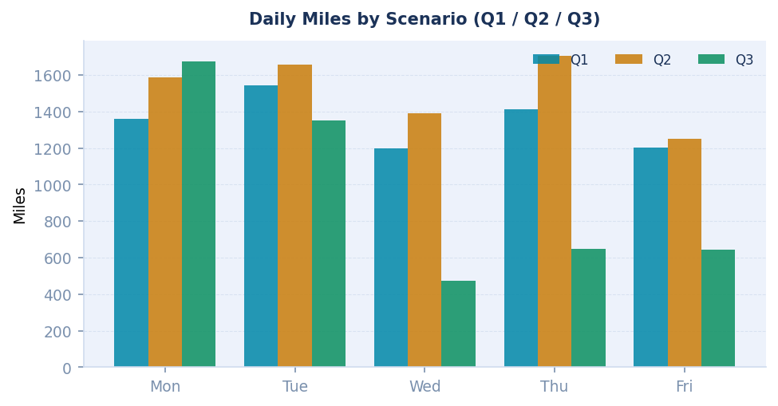
Figure 1. Daily miles by scenario — Q1 (teal), Q2 (amber), Q3 (green).
5. Scenario Q2: Heterogeneous Fleet
Q2 introduces Straight Trucks for the 60 orders that vans cannot serve — due to store access constraints, dock height limits, or delivery bay configurations. The remaining 201 orders stay flexible. The fixed schedule is preserved from Q1.
The problem with STs is capacity: 1,400 ft³ versus 3,200 ft³ for a van. Orders that could ride together on a single van must now be split across multiple ST runs. More runs mean more depot-to-stop and stop-to-depot legs, and those legs add mileage that has nothing to do with serving customers more efficiently. That is the mechanism behind Q2’s cost increase.
Day | Routes | Total Miles | Van Miles | ST Miles | Delta vs Q1
Monday | 6 | 1,585 | 1,451 | 134 | +224 mi
Tuesday | 7 | 1,656 | 1,422 | 234 | +113 mi
Wednesday | 7 | 1,392 | 1,286 | 106 | +196 mi
Thursday | 8 | 1,702 | 1,219 | 483 | +291 mi
Friday | 6 | 1,249 | 1,202 | 47 | +46 mi
TOTAL | 34 | 7,584 | 6,580 | 1,004 | +870 mi
Table 3. Q2 Mixed Fleet — daily breakdown by vehicle type.

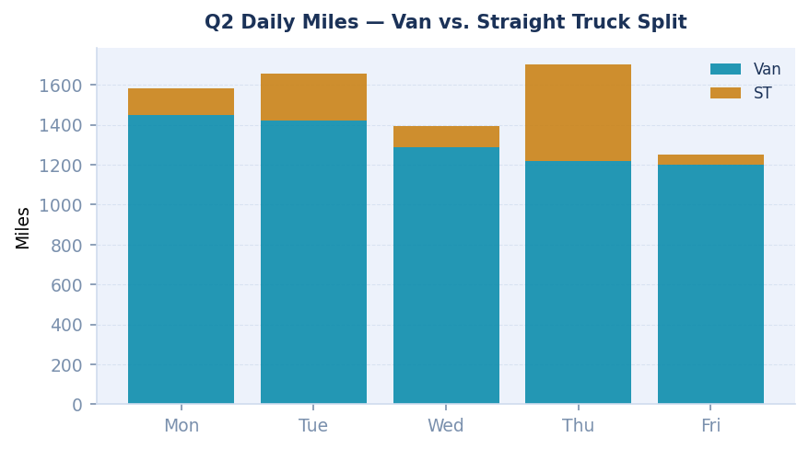
Figure 2. Q2 daily miles split between Van and Straight Truck routes.

Q2 needs 34 routes and 7,584 weekly miles — 870 more than Q1, a 13.0% increase. Annual mileage rises to 394,368 miles. Peak vehicle requirement climbs to eight (Thursday). For MAD contract negotiations, this 870-mile weekly premium (45,240 annual miles) must be explicitly priced in. At typical carrier rates of $2.50–$3.50 per mile, that is a $113,000–$158,000 annual gap that disappears if ST routes are bundled into a flat per-mile rate.
6. Scenario Q3: Relaxed Delivery Schedule
Q3 is where things get genuinely interesting. The only change from Q1 is that stores are no longer locked to a specific delivery day. Weekly frequency is preserved — every store still gets one delivery per week — but the day can shift. The algorithm is free to reassign stores to whichever day their geographic neighbors are being served. All constraints remain identical.
Schedule construction starts from Q1 and applies greedy swap improvements: each store is considered for reassignment to the day whose existing routes are geographically closest, measured by insertion cost. Swaps are accepted when they reduce total network mileage and leave the day’s routes feasible. The process repeats until no improving swaps remain.
Day | Routes | Orders | Volume (ft³) | Miles | Avg Mi/Route | vs Q1 Miles
Monday | 9 | 89 | 24,485 | 1,674 | 186.0 | +313 mi
Tuesday | 5 | 54 | 11,069 | 1,350 | 270.0 | −193 mi
Wednesday | 3 | 33 | 8,167 | 475 | 158.3 | −721 mi
Thursday | 6 | 68 | 16,017 | 649 | 108.2 | −762 mi
Friday | 3 | 17 | 5,691 | 645 | 215.0 | −558 mi
TOTAL | 26 | 261 | 65,429 | 4,793 | — | −1,921 mi
Table 4. Q3 Relaxed Schedule — daily breakdown with Q1 delta.

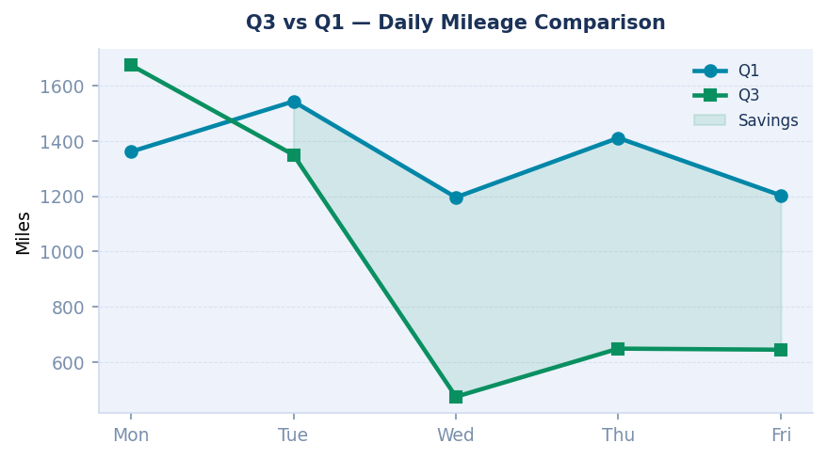
Figure 3. Q3 vs Q1 daily miles comparison — shaded region represents mileage saved.

Q3 needs only 26 routes and 4,793 weekly miles — 1,921 fewer than Q1, a 28.6% reduction. Annual mileage falls to 249,236, saving roughly 99,892 miles a year. Wednesday stands out most — three routes, 475 miles, 33 orders — versus six routes and 1,196 miles in Q1. The 28.6% reduction requires no capital investment, no change in delivery frequency, and no additional headcount.

7. Comparative Analysis and Discussion
The three scenarios tell a clear story when placed side by side. Q3 dominates Q1 on total mileage, and Q1 dominates Q2. But each scenario exposes a structurally different cost source — and each carries different implications for how NHG should approach the MAD negotiation.
Metric | Q1: Base Case | Q2: Mixed Fleet | Q3: Relaxed
Weekly Miles | 6,714 | 7,584 | 4,793
Annual Miles | 349,128 | 394,368 | 249,236
Total Routes/Week | 28 | 34 | 26
Peak Vehicles | 6 | 8 | 9
vs Q1 (weekly) | — | +13.0% | −28.6%
Annual Miles Saved | — | — | 99,892
Avg Miles/Route | 239.8 | 223.1 | 184.3
Table 5. Cross-scenario summary metrics.

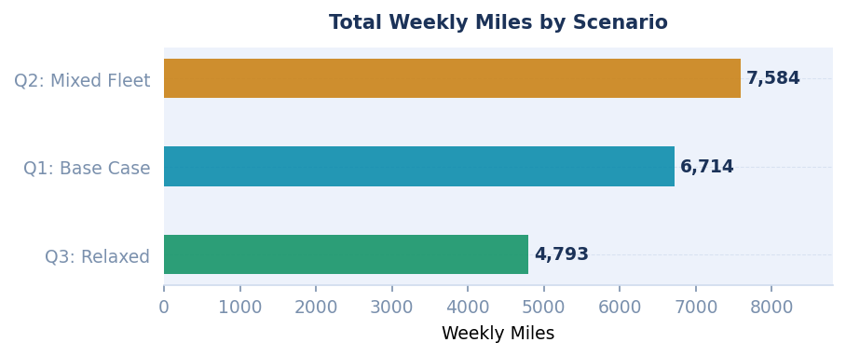
Figure 4. Total weekly miles by scenario — Q3 savings are substantial.

7.1 The Fleet Mix Effect
Comparing Q1 and Q2 isolates the Straight Truck penalty. The 870 additional weekly miles have nothing to do with more demand — the order set is identical. They come entirely from route fragmentation: ST capacity forces orders that a van could carry together onto separate runs, each with its own depot overhead. This penalty is structural and can only be mitigated by rethinking which orders are assigned to STs, or by pricing it explicitly in any MAD contract.

7.2 The Schedule Flexibility Effect
Comparing Q1 and Q3 shows what schedule flexibility is actually worth: 1,921 miles per week, 99,892 miles per year. The mechanism is geographic clustering — when stores near each other get served on the same day, routes become compact. This is not a routing inefficiency in the traditional sense. It is a structural reorganization of which demand is aggregated on which day.

7.3 Implications for the MAD Negotiation
Q1’s 349,128 annual miles is the right reference for a like-for-like comparison with MAD. Any MAD bid above this number needs to justify the premium with concrete service improvements. If the negotiation covers ST routes, the 45,240-mile annual premium must be priced separately. Q3’s 249,236 annual miles is a real, achievable target — NHG should use it as leverage in any contract discussion.

8. Conclusions and Recommendations
This study started with a straightforward question: what does NHG’s delivery operation actually cost, and what is realistically on the table if conditions change? The answer is clear. The base case costs 349,128 miles annually. Introducing Straight Trucks raises that by 13%. Relaxing the delivery schedule — without changing anything else — cuts it by 28.6% to 249,236 miles. That 99,892-mile gap represents roughly $250,000–$350,000 in potential annual cost reduction at typical carrier rates, and it requires no new investment, no added headcount, and no change in delivery frequency.

- Use Q1 (349,128 mi/year) as the MAD negotiating baseline. This is the most defensible reference point for a like-for-like comparison. Any MAD proposal above this number should require a clear explanation of the additional value being delivered.
- Price Straight Truck routes explicitly in any MAD contract. The 60 ST-mandatory orders carry a 45,240-mile annual surcharge. Bundling them under a single flat rate with van routes will obscure the true cost.
- Negotiate delivery day flexibility as a core contract term. Full flexibility yields Q3’s 28.6% reduction. Even partial flexibility — two or three days of adjustment — would likely capture a meaningful share. This is the highest-leverage operational change available to NHG.
- Set 249,236 annual miles as the long-term logistics benchmark. Whether the operation transfers to MAD or stays in-house, this defines what an efficient delivery network looks like for NHG’s current footprint. Include it as a quarterly KPI in any logistics services agreement.

8.1 Limitations and Future Work
Travel times are computed from straight-line distances at a uniform 40 mph. Real road networks introduce variability — highway versus local road differences, congestion in urban cores like Boston or Providence, seasonal weather — that the model abstracts away. Incorporating a live road network would improve time-feasibility estimates and surface additional consolidation opportunities in dense areas.
The model treats demand as fixed and known. In practice, weekly order volumes fluctuate by store, season, and promotion. A stochastic extension would generate probabilistic feasibility bounds and support better safety-stock sizing at the route level. This matters most for Q3, where Monday’s 89 orders leave less buffer for demand surges.
Finally, this study optimizes a single objective: total mileage. A multi-objective formulation minimizing mileage, driver overtime, and utilization variance simultaneously would produce a richer set of trade-off solutions. These extensions are left for future work.
Appendix A: Notation Summary
Symbol | Definition
G = (V, E) | Complete directed graph; V = nodes, E = arcs
0 | Depot node (ZIP 01887, Woburn MA)
n | Number of customer (delivery) nodes
qᵢ | Demand at node i (cubic feet)
sᵢ | Service (unloading) time at node i (minutes)
[aᵢ, bᵢ] | Time window at node i (earliest and latest arrival)
dᵢⱼ | Distance between nodes i and j (miles)
tᵢⱼ | Travel time = dᵢⱼ / 40 mph
Q | Vehicle capacity (3,200 ft³ van; 1,400 ft³ ST)
s(i,j) | Clarke-Wright savings: d(0,i) + d(0,j) − d(i,j)
Z | Objective value: total network mileage across all routes
Table A1. Mathematical notation used throughout this report.

10. References
Clarke, G., & Wright, J. W. (1964). Scheduling of vehicles from a central depot to a number of delivery points. Operations Research, 12(4), 568–581. https://doi.org/10.1287/opre.12.4.568
Cordeau, J. F., Gendreau, M., Laporte, G., Potvin, J. Y., & Semet, F. (2002). A guide to vehicle routing heuristics. Journal of the Operational Research Society, 53(5), 512–522. https://doi.org/10.1057/palgrave.jors.2601319
Dantzig, G. B., & Ramser, J. H. (1959). The truck dispatching problem. Management Science, 6(1), 80–91. https://doi.org/10.1287/mnsc.6.1.80
Gendreau, M., & Potvin, J. Y. (Eds.). (2010). Handbook of metaheuristics (2nd ed.). Springer. https://doi.org/10.1007/978-1-4419-1665-5
Golden, B., Raghavan, S., & Wasil, E. (Eds.). (2008). The vehicle routing problem: Latest advances and new challenges. Springer. https://doi.org/10.1007/978-0-387-77778-8
Laporte, G. (1992). The vehicle routing problem: An overview of exact and approximate algorithms. European Journal of Operational Research, 59(3), 345–358. https://doi.org/10.1016/0377-2217(92)90192-C
Lin, S. (1965). Computer solutions of the traveling salesman problem. Bell System Technical Journal, 44(10), 2245–2269. https://doi.org/10.1002/j.1538-7305.1965.tb04146.x
Or, I. (1976). Traveling salesman-type combinatorial problems and their relation to the logistics of regional blood banking (Doctoral dissertation). Northwestern University, Evanston, IL.
Savelsbergh, M. W. P. (1992). The vehicle routing problem with time windows: Minimizing route duration. ORSA Journal on Computing, 4(2), 146–154. https://doi.org/10.1287/ijoc.4.2.146
Solomon, M. M. (1987). Algorithms for the vehicle routing and scheduling problems with time window constraints. Operations Research, 35(2), 254–265. https://doi.org/10.1287/opre.35.2.254
U.S. Department of Transportation, FMCSA. (2023). Hours of service of drivers (49 C.F.R. Part 395). https://www.fmcsa.dot.gov/regulations/hours-service

